Interview questions on Quest global(Infineon)

**First round:**

1. Introduction
2. Question on the current mirror concept

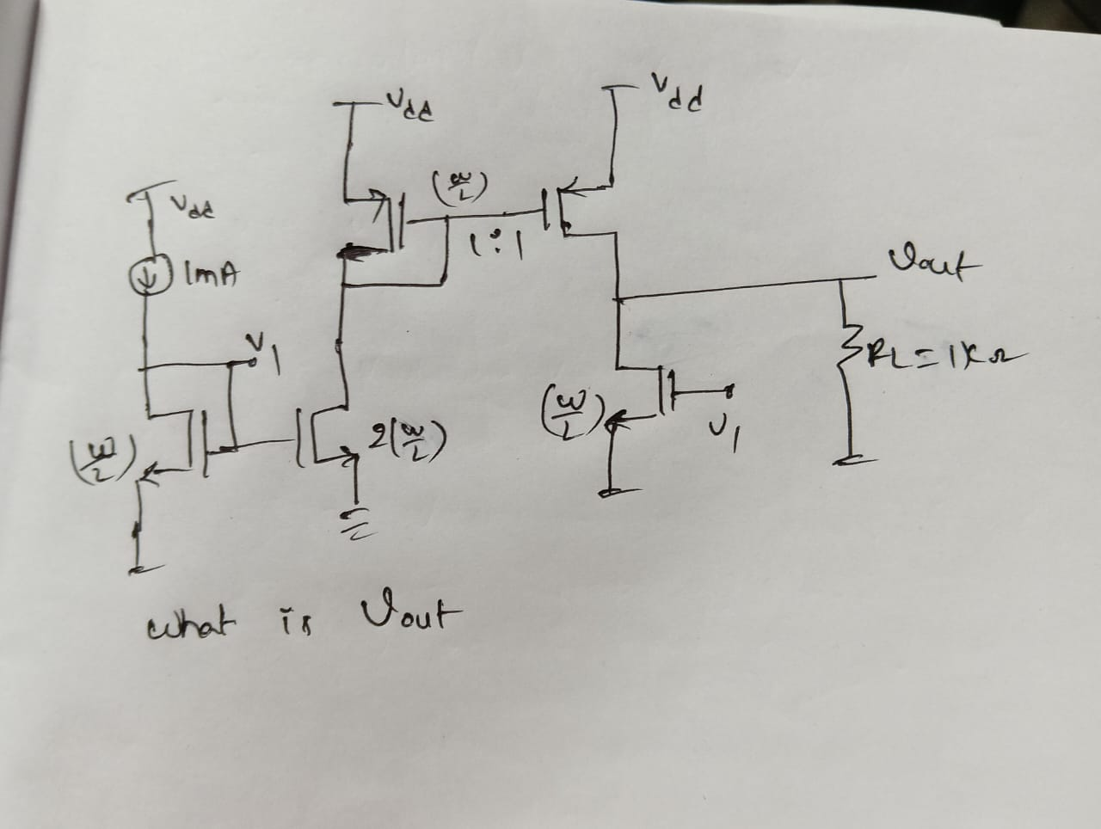

1. In a inverter(vdd=5), Pmos and Nmos had been replaced.. Now pulse of voltages applied with a pulse from 1 to 4 and 4 to -1 in the next cycle…draw the output waveform
2. Modelling of charge pump in pll (as per resume)
3. Why is modelling is used and how can you increase the simulation modelling.
4. What is the tool used for mixed signal simulation in cadence.

**Second round:**

1)Introduce yourself

2) Explaain any op-amp or LDO and how design procedure

3) Explain the buck regulator with waveforms

4) Write a electrical model to charge pump

5) A bit of verification flow(3 stages of flow).

6) Can you write digitally converted RC filter( they dropped the question later)

7) what test cases you check for buck regulator only functional checks not the corner simulation

8) How can you check line and load regulation as modelling engineer.

9) How will you verify reset, en, powerdown, resistor-trim (test-cases)